

Intelligent Tourist Guide System

A Software Project Submitted

By

|  |  |
| --- | --- |
| Name | ID |
| **Protick, MD Ashfaqur Rahman** | 15-29528-2 |
| **Rahman Ashiqur** | 15-30021-2 |
| **Reshmee, Himadri Das** | 15-28729-1 |
| **Salman, Md. Rifat** | 15-29393-1 |

Under the supervision of

**Abhijit Bhowmik**

Associate Professor

Department of Computer Science

Faculty of Science and Technology

American International University Bangladesh

Summer Semester 2017-2018

**Disclaimer**

This is to certify that this project is our original work. No part of this has been submitted elsewhere partially or fully for the award of any other degree. Any material reproduced in this project has been properly acknowledged.

________________________________________

1. Name: Protick Md Ashfaqur Rahman

ID No : 15-29528-2

________________________________________

2. Name: Rahman Ashiqur

ID No : 15-30021-2

________________________________________

3. Name: Reshmee Himadri Das

ID No : 15-28729-1

________________________________________

4. Name: Salman Md Rifat

ID No : 15-29393-1

**Approval**

The Software Project or Project titled “Intelligent Tourist Guide System” has been submitted to the following respected members of the Board of Examiners of the Faculty of Science and Information Technology in partial fulfillment of the requirements for the degree of Bachelor of Science in Software Engineering on 23th September 2018 by the following students and has been accepted satisfactory.

|  |  |
| --- | --- |
| ____________________________  **Abhijit Bhowmik**  Associate Professor & Supervisor  Department of Computer Science  American International University- Bangladesh | ____________________________  **Dr Md. Mahbub Chowdhury Mishu**  Head(Undergraduate)  Department of Computer Science  American International University- Bangladesh |
| ____________________________  **Professor Dr. Tafazzal Hossain**  Dean in Charge  Faculty of Science & Technology American International University-Bangladesh | **Dr. Carmen Z. Lamagna**  Vice Chancellor  American International University-Bangladesh |

**Acknowledgements**

We would like to take the chance to express our gratitude to our honorable teacher & Supervisor Abhijit Bhowmik, for his continuous guidance and support regarding this report. Besides this, we have found so many sincere and productive advices from many people that we would like pay homage to them. We convey our gratitude to our honorable Vice Chancellor, Dr. Carmen Z. Lamagna for encouragement.

Table of Contents

**Chapter 1: Statement of Work** 7

1.1 Purpose/Objectives 7

1.2 Scope 7

1.3 Proposed System 8

1.4 System Features 8

1.5 Environment 10

1.5.1 Organizations Involved 10

1.5.2 Processing 10

1.5.3 Security 11

1.6 Assumptions 11

1.7 Constraints 11

1.8 Proposed System 12

1.8.1 Description/Improvements of Proposed System 12

1.8.2 Resources 13

1.8.3 Hardware 13

1.8.4 Software 13

1.8.5 Operating Environment 13

1.9 Project Time & Cost 13

1.9.1 Project Period 13

1.9.2 Project Schedule 14

1.9.3 Domain & Hosting Package 14

1.10 Risk assessment 16

1.11 Assessing overall project risk 17

Chapter 2: Software Requirement Specification 19

2.1 Objectives and Scope 19

2.2 Overview of the Present System 19

2.3 Data Flow Diagram of the Present System 19

2.4 Weakness of the Present System 20

2.5 Overview of the Proposed System 20

2.6 Benefits of Proposed System 20

2.7 System Features 20

2.8 Hardware and Software Requirements 22

2.8.2 Hardware 22

2.8.3 Software 23

2.9 Human Resource Requirements 23

2.10 Constraints and Limitations 23

2.11 Budget 24

2.12 Conclusion 24

Chapter-3: Diagram 25

3.1 Use Case Diagram 25

3.1.1. Admin Functionality: 25

3.1.2. Staff Functionality: 26

3.1.3 Unregistered User: 27

3.1.4 Registered User: 27

3.2 Activity Diagram 29

3.3 Prototype 30

Chapter-4: Software Project Management Plan 34

4.1 Document History and Distribution 34

4.1.1 Revision History 34

4.1.2 Distribution 34

4.2 Overview 34

4.2.1 Purpose, Objectives and Project Scope 34

4.2.2 Project Scope 35

4.2.3 Assumptions and Constraints 35

4.3 Project Deliverables 35

4.3.1 The list of project deliverables is: 35

4.3.2 Schedule and Budget Summary 36

4.4 Evolution of the Software Project Management Plan 36

4.4.1 Definitions 36

4.5 Project Organization 37

4.5.1 External Interfaces 37

4.5.2 Internal Structure 37

4.5.3 Roles and Responsibilities 37

4.6 Managerial Process Plans 38

4.6.1 Project Start-up Plan 38

4.6.2 Estimation Plan 38

4.6.3 Staffing Plan 38

4.6.4 Resource Acquisition Plan 38

4.6.5 Project Staff Training Plan 38

4.7 Work Plan 39

4.7.1 Budget Allocation 39

Budget Allocation 39

4.8 Control Plan 39

4.8.1 Requirements Control Plan 39

4.8.2 Schedule Control Plan 40

4.8.3 Budget Control Plan 40

4.8.4 Quality Control Plan 40

4.8.5 Reporting Plan 40

4.8.6 Metrics Collection Plan 41

4.9 Risk Management Plan 41

4.10 Closeout Plan 41

4.11 Technical process plans 42

4.12 Process Model 42

4.13 Methods, Tools and Techniques 42

4.14 Infrastructure Plan 42

4.15 Product Acceptance Plan 42

4.16 Supporting Process Plans 43

4.17 Configuration Management Plan 43

4.18 Verification And Validation Plan 43

4.19 Documentation Plan 43

4.20 Quality Assurance Plan 44

4.21 Reviews and Audits Plan 44

4.22 Problem Resolution Plan 44

4.23 Subcontractor Management Plans 44

4.24 Process Improvement Plan 44

REFERENCES 45

# **Chapter 1: Statement of Work**

## Purpose/Objectives

|  |
| --- |
| Feasibility study will provide fundamental investigations into the potential benefits associated with this project. The main purpose of the feasibility study is to cover all issues associated with the project, and determine if the investment of time and other resources will lead to a desirable result. |

One of the most important aspects of the study is to ensure that the total investment needed to successfully bring the project to completion is considered. Often, this will include addressing components such cash reserves, labor, construction, production facilities, outsourcing, and the cost of raw materials. Only when the feasibility study has addressed the total cost of completing the project can the study progress to the next level.

As a second major component, the feasibility study will also address costs and other factors that are indirectly associated with the project.

The utilization of a feasibility study has often assisted companies in understanding which projects to develop and which ones to abandon before investing resources in something that ultimately shows no promise of generating revenue. Taking the time to engage in a pilot or feasibility study does involve some usage of available resources, but these costs are much more readily absorbed than the larger amount that would be expended on a project that ultimately proved to be worthless.

## 1.2 Scope

The scope of the project is much specified as it outlines the modern **Intelligent Tourist Guide System** to be incorporated in individual business models. Our system is divided into five phases those are:

* Development of a Day to Day Plan via web service or in person.
* Providing an efficient cost with transporation,hotel booking
* Customization and improvement of existing system.
* Individual information module for each resturant, place, transportaion, hotel, interesting things to do etc
* Individual information module for each client.

**Admin** has the highest authority over the entire system. Admin responsibilities consists of update or modify existing system, ensure data security and user authentication, cost fixing and efficient tour planing for clients, assign necessary role and privileges system users and as well as to the clients. Admin has the power to take away provided privileges that has been assigned to users or clients.

Tour Plan will make an efficient schedule with choisable places, transpotation, foods etc. Customer has to input the start point, destination , start and end date, number of people then the system will find a suitable plan with the estimated cost.

## 1.3 Proposed System

This software or Web Application is intended for implementing an **Intelligent Tourist Guide** system so that a customer can easily access to our service from anywhere, anytime. This system can make a customer’s travel a much easier.

Benefits /Improvements of Proposed System

* No hassle for organize trip schedule
* Client will refine their plan and system will find the best routes and schedules
* Best places & time to visit
* Transportation options
* Minimizes travel time
* Recommends how much time to spend
* Well planned budget for all type travelling
* Give preference every client according to their limitation of expense
* A complete day-by-day itinerary based on clients preferences and budgets
* Choises from the best hotels and activities
* Fast & safe booking
* Instant transaction history
* Client satisfaction
* Compliance with time

## 1.4 System Features

**Admin**

* Update/modify/create client.
* Update/modify/create system user.
* Update/modify/create role.
* Update/modify/create content details
* Update/modify/create of offers and speciality

**Unregisterd User**

* See/search contents (hotel, trips,transportation, reviews)
* Check availability of transpotation seat and hotel room and also their costs

**Registerd User**

* See/search contents
* Check availability of transpotation seat and hotel room and also their costs
* Make/customize day to day Schelude
* Book transporation seat, hotel room and also resturant table(depends on available)
* Save plans
* Set Trip Reminders
* Add a hotel, place,resturant to favorite list
* Give ratings

**Itinerary Planner**

* Adding Multiple Destination
* Adding Start and End Date
* Adding number of traveller with catagory
* Adding personal activities
* Adding transporation preference
* Adding budget limitation

**Day to Day Plan**

* Keeping log of all transaction history.
* Individual client wise payment module.
* Security and authentication verification.

**Individual Hotel Module**

* Hotel address, rating , cost, facalitites and other information
* Add to favourite option
* Add review
* Different type of offers (optional)

**Individual Resturant Module**

* Resturant address, ratings , food cost, special facalitites and other information
* Add to favourite option
* Add review
* Different type of offers (optional)

**Individual Client Module**

* Registered client’s account information and transaction history.
* Edit/Modify existing client information.
* Customization according to client choice.

**Booking**

* Viewing available seats(transportation) and rooms(accomodation)
* Assigning a particular available seat and rooms
* Different type of offers (optional)

**Payment**

* Keeping log of all transaction history.
* Individual client wise payment module.
* Security and authentication verification.

**Transaction Security**

* Login/Registration/Authentication and Validation process

## 1.5 Environment

## 1.5.1 Organizations Involved

Project Client: ABHIJIT BHOWMIK.

Developer: Intelligent Tourist Guide System team

User: Online Users or Customers

## 1.5.2 Processing

* This Web Application will have a graphical user interface which will be able to view by any browser
* That means it’s a website or web application which is browser independent.
* Two working modules. Administrator and Client
* This website will store the information of all registered user which can be viewed by user themselves and the administrator of this software.
* Authenticated & secure login system and secure data transmission for all user.
* Detailed log of all previous transaction.

## 1.5.3 Security

System’s security requirements:

* User authentication is required to access the application.
* A client or user must be a registered user to login to use the features.
* Without proper authentication no transaction will be allowed.

## 1.6 Assumptions

Some third party software may be use to build up this project. These are free components, most of them are open source. We have used Opera, Mozilla Firefox, and Google Chrome etc. as a web browser to access user interface as client application. So our project will not be affected because we are not using anything for which it becomes illegal to use.

Some open source libraries and software’s are used to build up this project:

* PHP ZIP files Library to use file compression.
* PHP Session to verify user login,
* For dynamic interface some Ajax library is used.
* MOO tools, JQuery

## 1.7 Constraints

* Usage outside regulation: Data passes from client to server through TCP/IP & we are not using any public key encryption service like SSL certificate. So we have constraints in case of passing user data. It may cause – Confidentiality, Integrity problems. Only registered users are valid & valid users can use the software through Client Application with help of Internet Browser on server side. For any missing password found by anonymous user, responsibility goes to valid user.
* Bandwidth limitations: It may lose server connection for technical error (Depends on Hardware/Internet connection). We need to run query again.
* Databases: Databases we are using MySql Database. User queries more than server’s limitations we need to check databases and refresh table data. In case of lack of DB caching.
* Parallel operations: Parallel use of other Internet application with this software may hamper in bandwidth, may occur taking time for a query for slow connections.
* Language requirements: Language is used in this software is PHP. Suppose any user wants Oracle Database we need to use bind variable technique.
* Communications protocols: Communication protocols we are using- TCP/IP to interact with the server. Other protocol is not considerable if user wants.
* Security considerations: If user doesn’t want to buy SSL security then client applications will not using any public key encryption service like SSL certificate (i.e. 128 bit RSA encryption). So we have constraints in case of passing user data.

It may cause (In case of internet security) –

* **Authentication problem:** Server may not recognize/confirm actual valid user.
* **Confidentiality problem:** User, intended server fails “understanding” message contents.
* **Integrity problem:** sender, server may fail to ensure message not altered without detection
* **Eavesdrop**: There may be Intercept messaging, actively insert messages into connection
* **Impersonation:** can fake (spoof) source address in packet (or any field in packet)
* **Hijacking:** “take over” ongoing connection by removing sender or server, inserting himself in place
* **Denial of service:** prevent service from being used by others (e.g., by overloading resources)

## 1.8 Proposed System

## 1.8.1 Description/Improvements of Proposed System

* Client’s satisfaction
* Reduce manpower cost
* Reduce the erroneous data entry
* Efficient, smooth and easy transaction
* Fast purchase/transaction.
* Monitor system performance efficiently (Depends on various factors)
* Reduce system loading time.

## 1.8.2 Resources

All the resource needed is provided below.

## 1.8.3 Hardware

➢ Minimum requirements for server:

* Processor: Xeon based microprocessor.
* RAM: 16 GB.
* System Type: Linux (64 bit).
* Storage: 256 GB SSD.
* For Storage Service: Network File System (NFS)

➢ Minimum requirements for client:

* Processor: Dual-core.
* RAM: 2 GB.
* System: Windows, MAC OS X, Linux.
* Web Browser: Firefox, Google Chrome, Opera

## 1.8.4 Software

* Notepad++ / Sublime Text.
* PHP, MySQL.
* Apache

## 1.8.5 Operating Environment

The system will be operated from the external (your preferred data center) Linux Serverin which site will be hosted. Hosting server has 99% Uptime. This website is platform independent. User application is accessible through various kinds of browsers like Opera, Mozilla Firefox, and Google Chrome etc. This website is a web application where client application has user interfaces through browser and main part is hosted on Apache Server. IBM or MAC any platform user can use. Operating System can be used Windows of any version from Windows 98, Windows XP/Vista to Windows 10, MAC OS X 10.5 or above.

## 1.9 Project Time & Cost

## 1.9.1 Project Period

* Expected time of completion of project is 4 months.

## 1.9.2 Project Schedule

|  |  |
| --- | --- |
| **Term** | **Description** |
| **BA** | **Business Analyst** |
| **PM** | **Project Manager** |
| **D** | **Developer** |
| **QT** | **Quality Tester** |

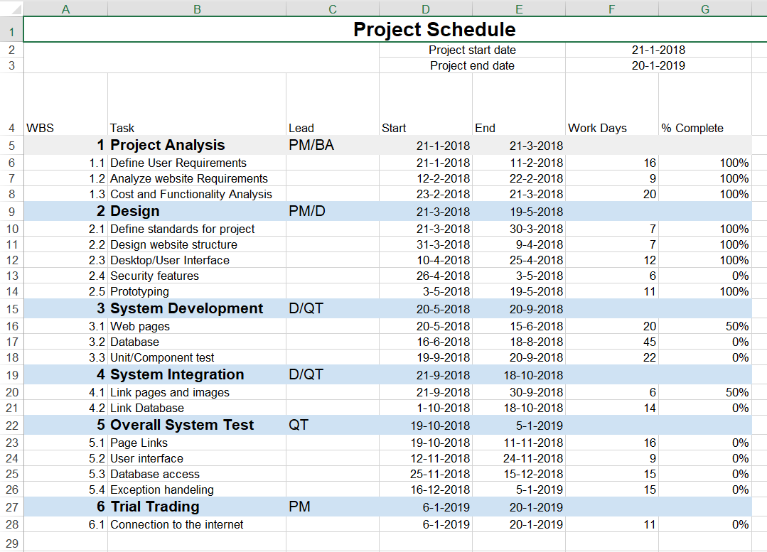

## 1.9.3 Domain & Hosting Package

**Domain**

* **.com** 950 tk/yr
* **.net** 950 tk/yr
* **.org** 950 tk/yr
* **.biz** 850 tk/yr
* **.info** 850 tk/yr
* **.xyz** 200 tk/yr

**Hosting Package A:** Great for small websites

* Web Space: 1GB SSD Storage
* Bandwidth: 30GB/monthly
* RAID 10 SSD Server
* Unlimited Sub Domains
* Unlimited Email Accounts
* Unlimited Databases
* Tk. 1500/Year

**Hosting Package B:** Perfect for medium sized websites

* 3GB SSD Storage
* 90 GB Bandwidth Monthly
* RAID 10 SSD Server
* LiteSpeed Web Server
* Three Addon Domains
* Unlimited Sub Domains
* Unlimited Email Accounts
* Unlimited Databases
* Tk. 2500/year

**Hosting Package C:** For the demanding sites

* 5 GB SSD Storage
* 150 GB Bandwidth Monthly
* RAID 10 SSD Server
* LiteSpeed Web Server
* Five Addon Domains
* Unlimited Sub Domains
* Unlimited Email Accounts
* Unlimited Databases
* Tk. 3500/year

**Hosting Package C:** For the highly demanding sites

* 20 GB SSD Storage
* 500 GB Bandwidth Monthly
* RAID 10 SSD Server
* LiteSpeed Web Server
* Nine Addon Domains
* Unlimited Sub Domains
* Unlimited Email Accounts
* Unlimited Databases
* Tk. 7000/year

**Estimated service cost**

|  |  |
| --- | --- |
| **Description** | **Cost Assumption** |
| Site launch (hosting) | 20,000 BDT |
| Maintenance (1 year) | 50,000 BDT |
| Developers | 1,25,000 BDT |
| **Grand total** | **1,95,000 BDT** |

## 1.10 Risk assessment

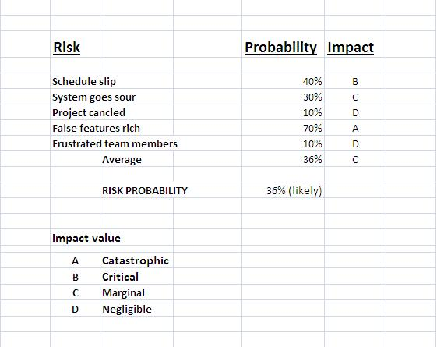

The impact of each risk driver on the risk component is divided into one of four impact categories—negligible, marginal, critical, or catastrophic.

|  |  |  |  |  |
| --- | --- | --- | --- | --- |
|  | **Catastrophic** | **Critical** | **Marginal** | **Negligible** |
|  |  |  |  |  |
| **Schedule slip** |  | Project delay, exceed budget |  |  |
| **System goes sour** |  |  | Grading miscalculation, Unauthorized access |  |
| **Project canceled** |  |  |  | Booking cancelation |
| **False features rich** | System doesn’t give proper output.  Unable to fulfill requirement |  |  |  |
| **Frustrated team members** |  |  |  | Fail to meet deadline |

## 1.11 Assessing overall project risk

**1. Have software engineer team formally committed to support the project?**

**Answer:** Yes. All the members are formally committed to support the project. They also ensure that they will give all types of available facilities.

**2. Are requirements fully understood by the software engineering team and their customers?**

**Answer:** Yes. As the software engineering team or the developers has the sound knowledge about the requirements so it is easily understandable by the team. The requirements details are well organized also informative, so it is under stable by the customers.

**3. Are end-users enthusiastically committed to the project and the system/product to be built?**

**Answer:** Yes. Because the end-users are expecting that, they will be able to find all kind of information about Chain Store Management System.

**4. Have user been involved fully in the definition of requirements?**

**Answer:** Yes. The user has been fully involved in the definition of requirements. They are aware of the application requirements.

**5. Is project scope stable?**

**Answer:** Yes. Project scope is stable because the minimum and mandatory scope is almost covered by the software engineering team. If any further scope will arise then just adding it with the old ones.

**6. Does the software engineering team have the right mix of skills?**

**Answer:** Yes. The software engineering team has the right mix of skills. The team members have the capability of doing their work in a team, ability to work in pressure and also have sound knowledge according to the software implementation.

**7. Are project requirements stable?**

**Answer:** Yes. Currently all possible requirements are being listed, and seem that if anything would be added later to the list will not make the project unstable. All requirements for this project are easily available that will enthusiast the end-user to use it.

**8. Does the project team have experience with the technology to be implemented?**

**Answer:** Yes. The project team has experience with the technology to be implemented because they have the sound knowledge about the technologies and the technologies are also implemented by them before.

**9. Does the project team and client are aware about the possible risks?**

**Answer:** Yes. Project team prepare the possible risk assessment and aware of handling the risk. Client is also being notified

# Chapter 2: Software Requirement Specification

## 2.1 Objectives and Scope

The scope of the project is to simplify the trip planning process. Inspirock provides a detailed day-by-day plan of attractions you will see at the various destinations on your personalized itinerary. The plan is completely customizable with options you can choose on the home page and by adding and deleting recommended attractions and destinations.

The Tourist Guide System is supposed to have the following features:

* A complete day-by-day itinerary based on users preferences
* Users refine their plan and System find the best routes and schedules
* System provides the users to book prefered hotel and activities and also transportation
* Individual information module for each client.
* The system lets the administrator who has the highest authority manage the users and the bookings and the content of the system.
* User can give ratings to Spots, Hotels, Transportations and can add to their favourites and also save their plans.

The features that are described in this document are used in the future phases of the software development cycle. The features described here meet the needs of all the users.

## 2.2 Overview of the Present System

Currently there are very few system like TripAdvisor, Ticketshala, MakeMyTrip implemented in Bangladesh that are based only on finding and book hotels and transpotation and spots.

Inspirock has the facility to customize the travelling plan and book the ticket but it has a much lacking in best and effective route details for Bangladesh and its has less transporation details also except flights.

## 2.3 Data Flow Diagram of the Present System

Not required.

## 2.4 Weakness of the Present System

* Most of the routes are not effective
* Less information and availabilty all kind of trasnportations
* No Itinerary Planner

## 2.5 Overview of the Proposed System

Proposed system will have the customize plans based on clients budget and preferences and an effective routes , schedule & transporation details which will all kind of travellers. Booking facilities will make this system complete package.

## 2.6 Benefits of Proposed System

**Benefits /Improvements of Proposed System**

* No hassle for organize trip schedule
* Client will refine their plan and system will find the best routes and schedules
* Best places & time to visit
* Transportation options
* Minimizes travel time
* Recommends how much time to spend
* Well planned budget for all type travelling
* Give preference every client according to their limitation of expense
* A complete day-by-day itinerary based on clients preferences and budgets
* Choises from the best hotels and activities
* Fast & safe booking
* Instant transaction history
* Client satisfaction
* Compliance with time

## 2.7 System Features

**Admin**

* Update/modify/create client.
* Update/modify/create system user.
* Update/modify/create role.
* Update/modify/create content details
* Update/modify/create of offers and speciality

**Unregisterd User**

* See/search contents (hotel, trips,transportation, reviews)
* Check availability of transpotation seat and hotel room and also their costs

**Registerd User**

* See/search contents
* Check availability of transpotation seat and hotel room and also their costs
* Make/customize day to day Schelude
* Book transporation seat, hotel room and also resturant table(depends on available)
* Save plans
* Set Trip Reminders
* Add a hotel, place,resturant to favorite list
* Give reviews

**Itinerary Planner**

* Adding Multiple Destination
* Adding Start and End Date
* Adding number of traveller with catagory
* Adding personal activities
* Adding transporation preference
* Adding budget limitation

**Day to Day Plan**

* Keeping log of all transaction history.
* Individual client wise payment module.
* Security and authentication verification.

**Individual Hotel Module**

* Hotel address, rating , cost, facalitites and other information
* Add to favourite option
* Add review
* Different type of offers (optional)

**Individual Resturant Module**

* Resturant address, ratings , food cost, special facalitites and other information
* Add to favourite option
* Add review
* Different type of offers (optional)

**Individual Client Module**

* Registered client’s account information and transaction history.
* Edit/Modify existing client information.
* Customization according to client choice.

**Booking**

* Viewing available seats(transportation) and rooms(accomodation)
* Assigning particular available seats and rooms
* Book ticket by date and member number
* Different type of offers (optional)

**Payment**

* Keeping log of all transaction history.
* Individual client wise payment module.
* Security and authentication verification.

**Transaction Security**

* Login/Registration/Authentication and Validation process

## 2.8 Hardware and Software Requirements

## 2.8.2 Hardware

➢ Minimum requirements for server:

* Processor: Xeon based microprocessor.
* RAM: 16 GB.
* System Type: Linux (64 bit).
* Storage: 256 GB SSD.
* For Storage Service: Network File System (NFS)

➢ Minimum requirements for client:

* Processor: Dual-core.
* RAM: 2 GB.
* System: Windows, MAC OS X, Linux.
* Web Browser: Firefox, Google Chrome, Opera

## 2.8.3 Software

* Notepad++ / Sublime Text.
* PHP, MySQL.
* Apache

## 2.9 Human Resource Requirements

The total human resource needed for implementing and operating the system is mentioned below.

* **Hardware Specialist**: A part time hardware specialist is needed to manage all the computers of the centre. So in case of any hardware failure he/she may come and solve the problem.
* **Computer operator/Data entry operator**: A computer operator is needed to upload the online question to the system in case specific user lacks the systems know how.

## 2.10 Constraints and Limitations

**Assumptions and Dependencies**

* The users have sufficient knowledge of computers.
* The user’s computer should have Internet connection and Internet server capabilities.
* The users know the English language, as the user interface will be provided in English.

**Constraints**

* Bandwidth limitations: It may lose server connection for technical error (Depends on Hardware/Internet connection). We need to run query again.
* Databases: Databases we are using Oracle Database. User queries more than server’s limitations we need to check databases and refresh table data.
* Parallel operations: Parallel use of other Internet application with this software may hamper in bandwidth, may occur taking time for a query for slow connections.
* Language requirements: If any user wants to use any language other that what we used for Oracle Database, we need to use bind variable technique.
* Communications protocols: Communication protocols we are using- TCP/IP to interact with the server. Other protocol is not considerable, if user wants.

## 2.11 Budget

|  |  |
| --- | --- |
| **Description** | **Cost Assumption** |
| Site launch (hosting) | 20,000 BDT |
| Maintenance (1 year) | 50,000 BDT |
| Developers | 1,25,000 BDT |
| **Grand total** | **1,95,000 BDT** |

## 2.12 Conclusion

This Requirement Specification Document has been developed based upon by the studying common scenario and previous experience of the project manager. Thus any unusual circumstances rise on the process of development may derail the values and time frame mention in this document

# Chapter-3: Diagram

## 3.1 Use Case Diagram

## 3.1.1. Admin Functionality:

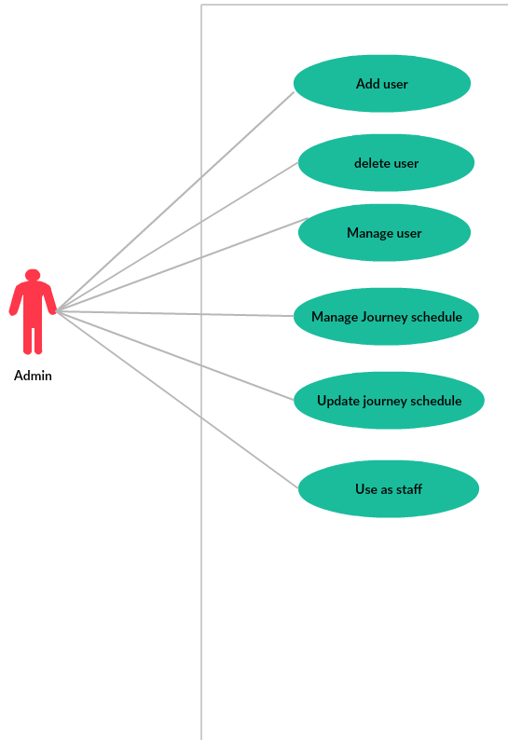

The functionality of an admin is as follows:

* Adding a new user
* Delete an existing user
* Can manage users
* Manage journey schedule
* Update journey schedule
* Behave as a staff.

## 3.1.2. Staff Functionality:

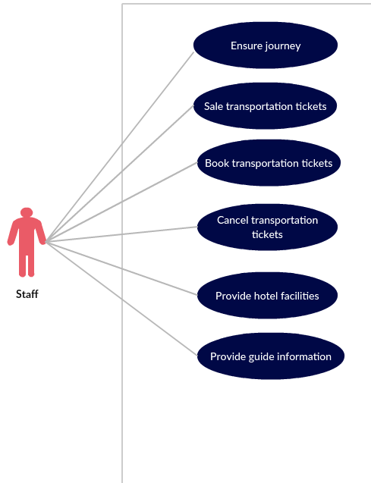

The functionality of a staff is as follows:

* Ensure users itinenary journey plan
* Can sale transportation tickets for user
* Can book transportation tickets for user
* Cancel transportation tickets
* Provide hotel facilities
* Provide guide facilities

## 3.1.3 Unregistered User:

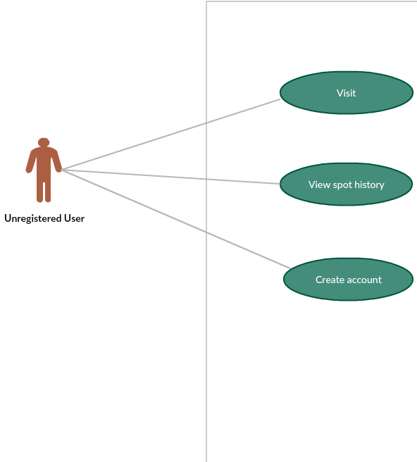

The function of Unregistered user:

* Create an account
* Can visit the website
* View spot history and information

## 3.1.4 Registered User:

**:**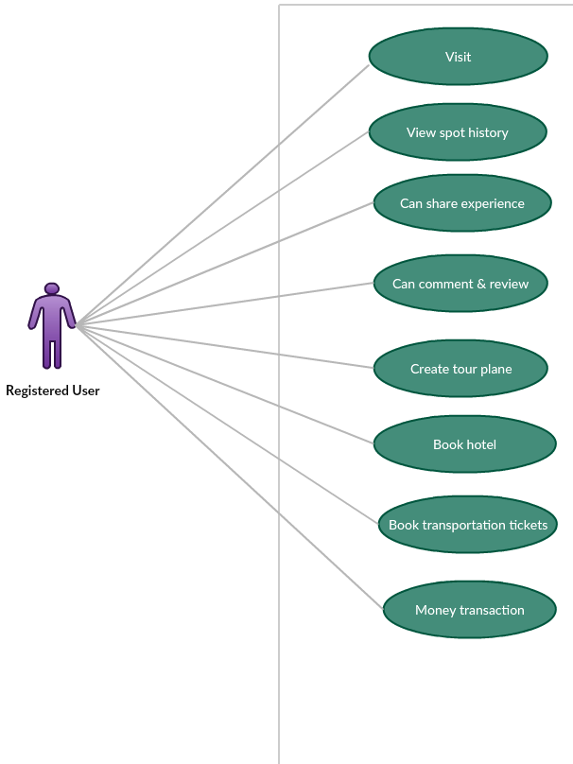

The function of Registered user:

* Can visit website
* View spot information and history
* Can share their tour’s experience by post
* Can comment and review of hotel, transportation and spot
* Create tour plan by special feature (ITINERARY PLANNER)
* Can book hotel
* Can book transportation tickets
* Money transaction

## 3.2 Activity Diagram

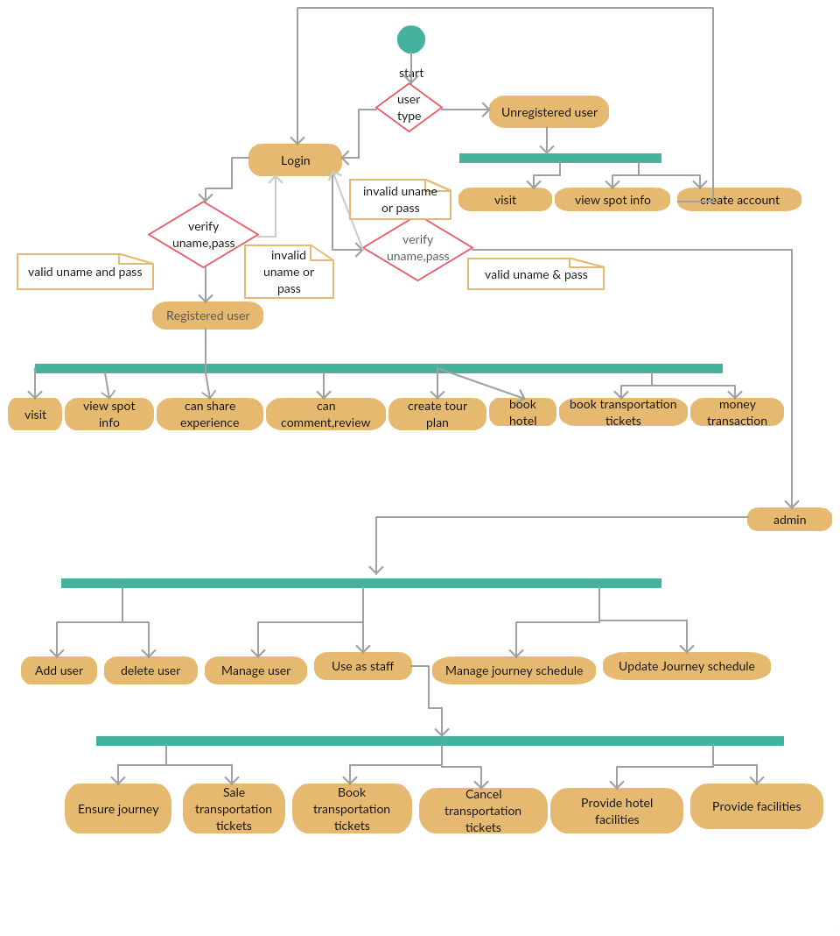

## 3.3 Prototype

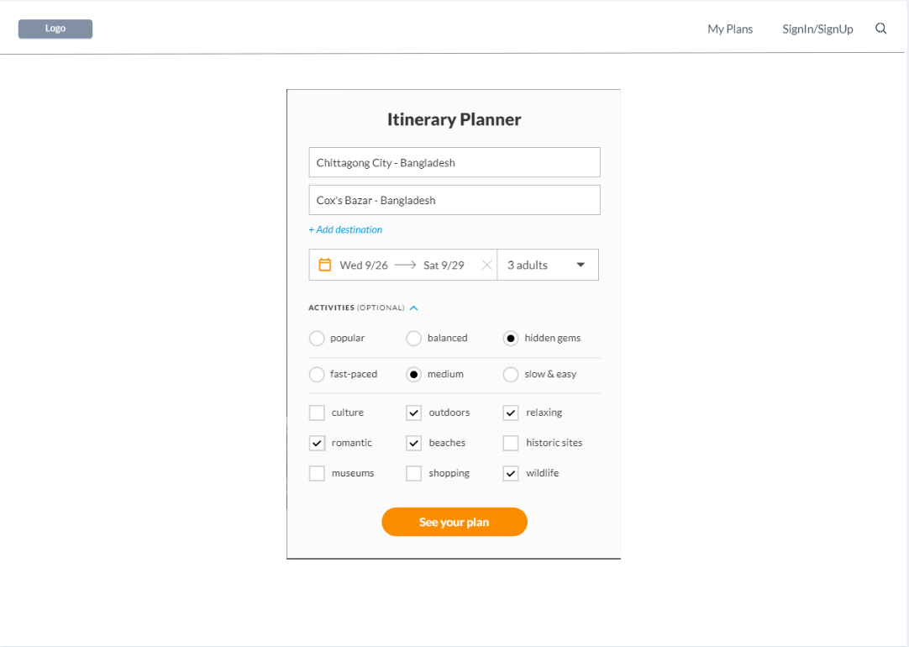

Itinerary Planner

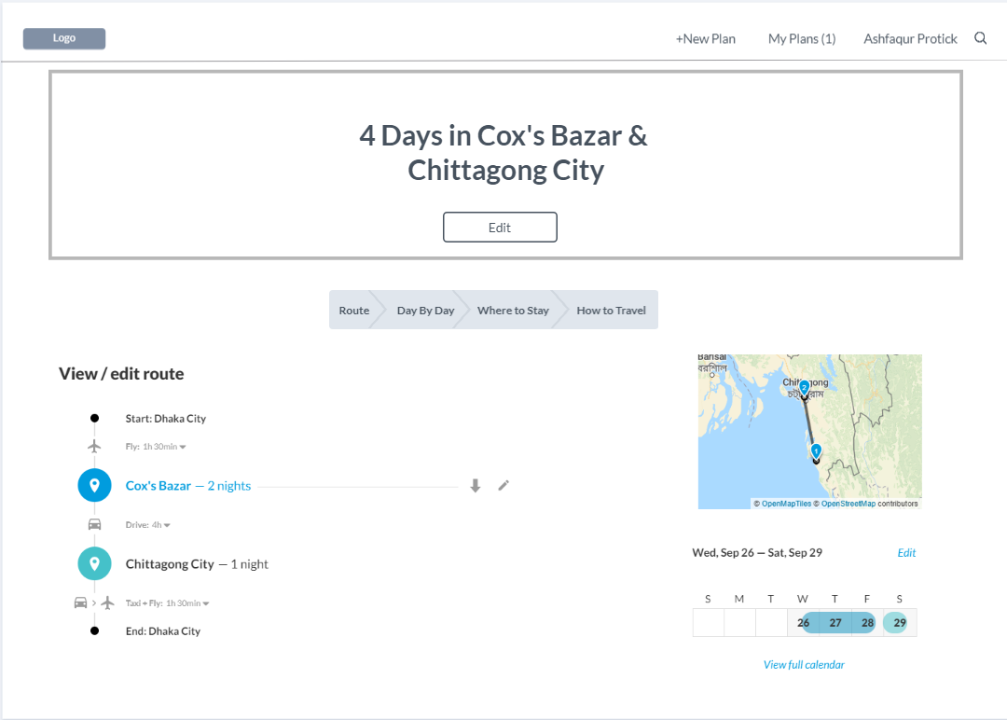

Route

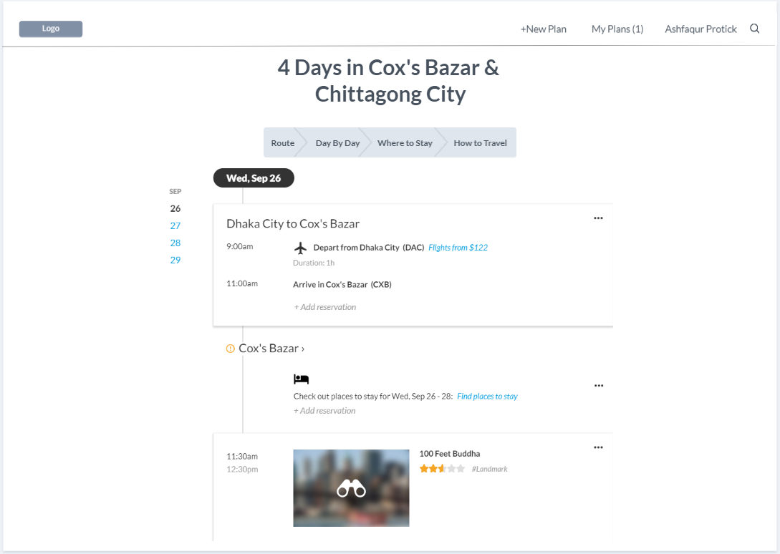

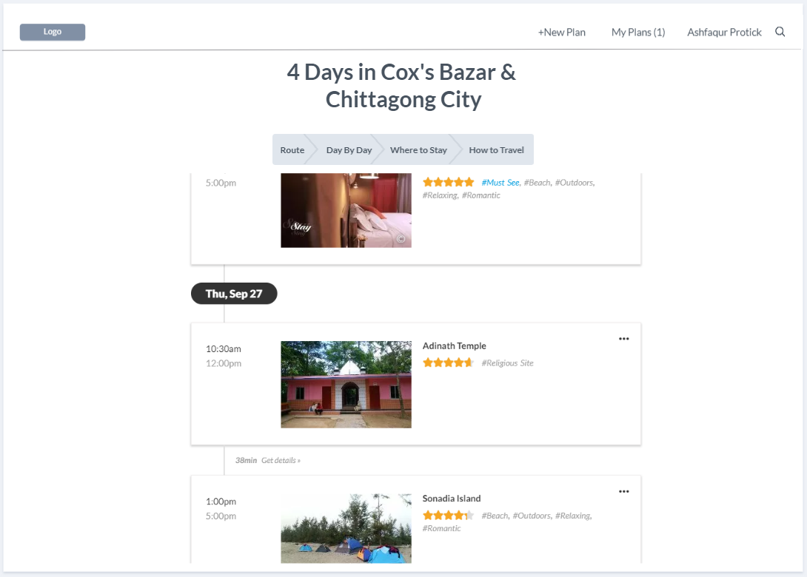

Day by Day Plan with Spots

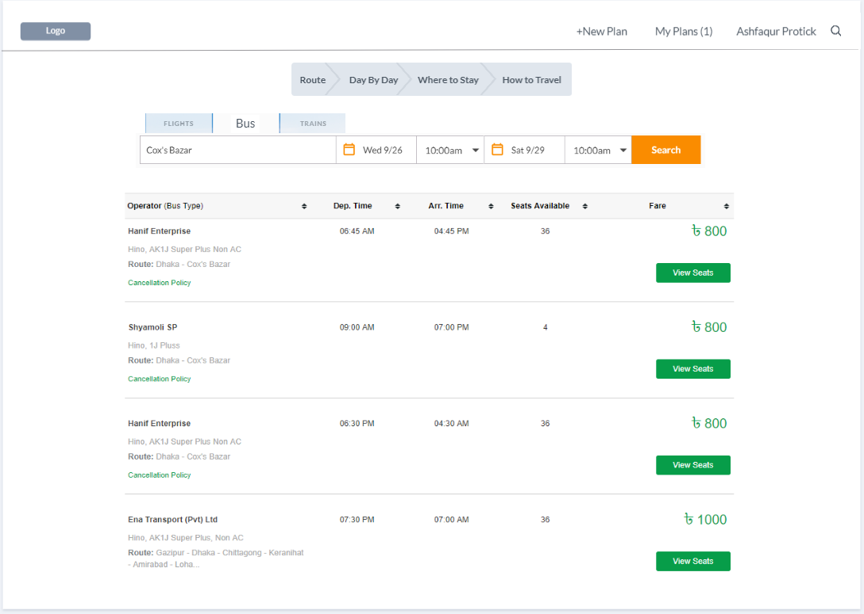

Transportation (How to Travel)

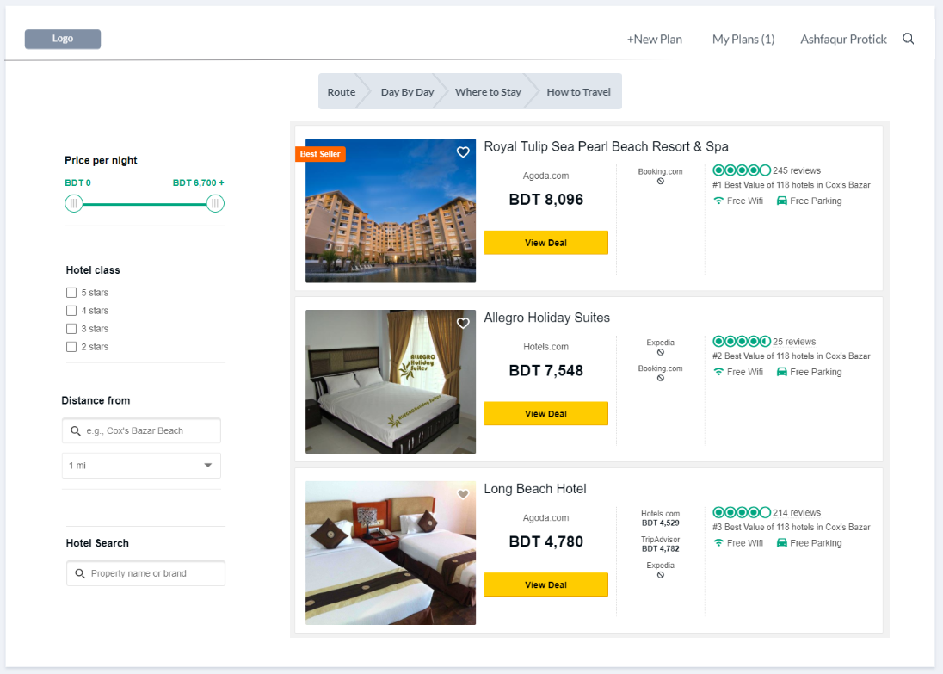

Hotels (Where to Travel)

# Chapter-4: Software Project Management Plan

## 4.1 Document History and Distribution

The development Intelligence Tourist Guide System is a knowledge based system where user can get all kind of information of tourist spots. Also users can enjoy an online ticket and hotel booking experience. Users can benefit from this service by saving valuable time.

## 4.1.1 Revision History

|  |  |  |  |
| --- | --- | --- | --- |
| **Revision #** | **Revision Date** | **Description of Change** | **Author** |
| 01 | March 21th , 2019 | Primary Phage | Ashiqur Rahman |
| 02 | March 24th , 2019 | Yes | Ashfaqur Rahman |

These versions will show up there and also on its service work good.

## 4.1.2 Distribution

|  |  |  |
| --- | --- | --- |
| **Recipient Name** | **Recipient Organization** | **Distribution Method** |
| Abhijit Bhowmik | AIUB | Hard Copy, Soft Copy |
| Abhijit Bhowmik | AIUB | Hard Copy, Soft Copy |

Soft copy and Hard copy Distributed copy mention on the table.

## 4.2 Overview

## 4.2.1 Purpose, Objectives and Project Scope

The main objective of this document is to illustrate the requirements of the travelling project. The document gives the detailed description of the both functional and non-functional requirements for this system. The document is developed after a number of studying the requirement specifications paper of the given Project. The final product of the team will be meeting the requirements of this document.

## 4.2.2 Project Scope

* To development **Tourist Guide System** where Users will feel easy to get information.
* This system makes the administrative work easy.
* Multiple opportunities in one system like book hotel and vehicles.

## 4.2.3 Assumptions and Constraints

The assumptions during the projects are-

* The development team has not quite enough experience as a whole to complete the project.
* Additional resources (people or money) are not available for the project.

## 4.3 Project Deliverables

## 4.3.1 The list of project deliverables is:

1. Statement of Work (SOW)
2. Software Requirements Specification (SRS)
3. Software Project Management plan (SPMP)
4. Software Design Plan (SDP)

## 4.3.2 Schedule and Budget Summary

|  |  |
| --- | --- |
| **Schedule** | |
| **Milestone or Major Project Deliverable** | **Planned Completion Date(Day)** |
| SOW | September 16th , 2018 |
| SRS | September 30th , 2018 |
| SPMP | October 7th , 2018 |
| SDP | October 21th , 2018 |
| Soft testing plan | October 28th , 2018 |
| Presentation & project progress | November 4th , 2018 |
| Technical documentation | With completed product |
| Software evaluation report | Along with final submission |

## 4.4 Evolution of the Software Project Management Plan

The preliminary drafts of the SPMP will be submitted to the project manager and after approval; copies of the same will be distributed to the members of the group on the date as referred to in section 1.1.4.

## 4.4.1 Definitions

|  |  |
| --- | --- |
| **Terms** | **Description** |
| 1. SOW | Statement of Work |
| 1. SRS | Software Requirement Specification |
| 1. SPMP | Software Project Management Plan |
| 1. SDP | Software Design Plan |
| 1. SQATP | Software Quality Assurance and Testing Plan |
| 1. Impact | 1-catastrophic  2-critical  3-marginal  4-negligible |

## 4.5 Project Organization

Project organization depends on three major Structures

## 4.5.1 External Interfaces

The system users relationship will be responsible for formal interaction between the developer’s team and the customer contact. Necessary interaction will be done through anyone on the team, but all discussions with the user will be documented clearly for record. All user requests for services or configuration item changes will be in writing and approved by the project’s Configuration Control Board (CCB), which consists of all team members.

## 4.5.2 Internal Structure

There are four developers for this project. All members have specified areas of responsibility and everybody contributes equally to the project. Because there are only four members on the team, each member holds more than one role.

The team members will change roles throughout the life of the project, and each member will continue to have more than one role.

## 4.5.3 Roles and Responsibilities

The software developers are responsible for all documentation to be developed and also for all work to be done.

## 4.6 Managerial Process Plans

## 4.6.1 Project Start-up Plan

This section describes the materials and resources required to start the project. Because most of this information was pre-defined for the team, this section will not describe the rationale for many of these choices.

## 4.6.2 Estimation Plan

As previously stated in that, the total development time is estimated to be 6 days and the total internal cost to be BDT. These figures were obtained by expert judgment by analogy, that is, by comparison with similar projects.

## 4.6.3 Staffing Plan

Each team member will be available for 8 hours per day as the project purpose. This time includes the team and supervisor meetings, document preparation and inspection, and tool development.

## 4.6.4 Resource Acquisition Plan

* All resources for the project will be available at the start of the project and will not change substantially over time. Below are the planned changes: The technical writer will change after completing a documentation
* The team member’s roles will change according to project needs

## 4.6.5 Project Staff Training Plan

No additional staff training is needed for this project**.**

## 4.7 Work Plan

Work Activities and Schedule Allocation

## 4.7.1 Budget Allocation

|  |  |  |
| --- | --- | --- |
| Budget Allocation | | |
|  | **Hours** | **Costs** |
| **Agency Labor** |  |  |
| **Contract Labor** | N/A | 0 BDT |
| **Non-Labor Costs** | N/A | 0 BDT |
| **Total Hours / Implementation Cost** |  |  |

## 4.8 Control Plan

## 4.8.1 Requirements Control Plan

When changes are to be made in the requirements after the Software Requirement Specification has been released, the changes shall be brought to the attention of the developers and discussed. Any changes that are to be made will be with the prior approval of the supervisor and only if feasible and permissible within the constraints of the project and resources in terms of knowledge and skill of the developers required. Once the changes have been made to the Software Requirement Specification document, an updated version of the Software Requirement Specification will be released.

## 4.8.2 Schedule Control Plan

If the work scheduled in section 1.1.4 is gets behind, the developer will be ready to spend extra time on the project in between and after the schedules to make up for the lost time and deliver the final project on time.

## 4.8.3 Budget Control Plan

Average monthly income will be determined by totaling all earnings for the year and dividing by 12. Average monthly spending will be generated by tracking all expenditures. "The difference between "Budget" and "Current Spending" will be the savings. If expenditure exceeds the income than steps may be follow to cut back on expenditures, depending on the specific savings goals. Expenses are monitored by the project manager, and reported and accessed via the Weekly Status Report.

## 4.8.4 Quality Control Plan

Any major changes that affect the milestones or the budget will have to be approved by all and documented. All will be responsible for ensuring that the project will be completed on time and within budget. This will be accomplished through daily meetings of the team members with the supervisor. At each meeting, developer team will present the day’s progress and problems. Al will determine whether they are progressing as expected and whether they are following the specification document and the project management plan. Any major problems faced by the team members will immediately be reported to all.

## 4.8.5 Reporting Plan

The updated Software Project Management Plan will be circulated as mentioned in schedule of section 1.1.4. Each of preliminary versions of all the documents and updates and status reports will be sent and discussed with the advisor and upon approval the approved document will be circulated to the other members of the team. The report on the status of the project will be sent to the members of the team.

## 4.8.6 Metrics Collection Plan

As the system based on object oriented so the metrics focus on measurement that can be applied to the class and the design characteristics—localization, encapsulation, information hiding, inheritance, and object abstraction techniques—that make the class unique.

## 4.9 Risk Management Plan

|  |  |  |  |  |
| --- | --- | --- | --- | --- |
| **Risks** | **Probability** | **Impact** | **Rating** | **RMMM** |
| Project Manager Availability | 50% | 3 | Medium | R-1 |
| Schedule slips | 70% | 1 | High | R-2 |
| System goes hour | 60% | 3 | Medium | R-3 |
| Project canceled | 30% | 4 | Low | R-4 |
| False feature rich | 40% | 2 | Low | R-5 |
| Programmers doesn’t have good experience | 50% | 3 | Medium | R-6 |
| Late delivery | 50% | 3 | Medium | R-7 |
| Customer Participation in Beta Testing | 30% | 4 | Low | R-8 |

## 4.10 Closeout Plan

At the end of the project, the following actions will occur:

* The developers team will make a hard copy file of all documents, source code, plans, etc. generated by the team.
* The developers team will also copy of all material in electronic format on a CD-ROM.

## 4.11 Technical process plans

The Software Project Management Plan will specify the development process model, technical models, tools and techniques that will be used to develop the work products, project infrastructure and product acceptance plan.

## 4.12 Process Model

The XP (extreme Programming) agile process model will be follow during the project implementation.

## 4.13 Methods, Tools and Techniques

The project, E-Commerce, adapts the system on Personal Computer using HTML, PHP, Visual Studio 2012 and MySQL for database management system. Additional tools that will be used are: Adobe Dreamweaver, Adobe Photoshop etc.

## 4.14 Infrastructure Plan

The hardware resources are three Intel Core2Duo Personal Computers running Windows XP/Vista or UBUNTU operating system. The project using software resources are like Notepad ++, Adobe Dreamweaver, Adobe Photoshop, Adobe Flash, XAMPP, Wamp etc.

## 4.15 Product Acceptance Plan

Every milestone of the project will be accepted formally by the project manager by signing appropriate acceptance documentation. At the end of every phase the project manager will perform an acceptance test. This may result in additional requests for change and improvements. The project manager will test the final product/application for acceptance.

## 4.16 Supporting Process Plans

The Software Project Management Plan will include the plans for the supporting processes that are part of the software project. These plans include: configuration management plan, verification and validation, software documentation, quality assurance, reviews and audits, problem resolution and subcontractor management.

## 4.17 Configuration Management Plan

All the project deliverables are to be considered as configuration items. The configuration item as well as its file would be named after the document like SOW, SRS and followed by the version number. For example, all the preliminary versions that are submitted to the project manager for review would be named with the abbreviation followed by 0.1, 0.2. After the project manager approves the basic SPMP, this baseline document will be version 1.0 and is distributed to the project members. Informal updates with the project manager will be numbered with 1.1, 1.2, etc. and the next full distribution to the committee would be version 2.0, etc.

## 4.18 Verification And Validation Plan

The Software Project Management Plan for this project shall contain the verification and validation plan for the software project and it shall include tools, techniques and responsibilities for the verification and validation work activities. The verification and validation plan will be part of a separate document and will be maintained accordingly

## 4.19 Documentation Plan

The IEEE standards would be followed for all documentation purposes. All the documents would be discussed and reviewed with project manager before their baseline versions are issued and distributed to the members of the committee on the due dates.

## 4.20 Quality Assurance Plan

The quality of our project will be maintained and checked by the project manager. He will assure that this project is maintaining the quality.

## 4.21 Reviews and Audits Plan

Review and Audits would be addressed as a part of the Software Quality Assurance and Verification & Validation Plan that would be developed following recommended departmental standards.

## 4.22 Problem Resolution Plan

All problems would be resolved informally the developer and the project manager. That is, there is no specific plan. But, The Software Project Management Plan will be updated accordingly should the need for such a plan arises.

## 4.23 Subcontractor Management Plans

The project does not have any plan for managing subcontractors that may contribute work products to the software project.

## 4.24 Process Improvement Plan

After the development, the project will be regularly checked by the project manager and he will suggest the developers if any kind of improvement is needed.

## REFERENCES

1. OMG. “Unified Modeling Language Specification”, Superstructure Version 2.1.1, Febrer 2007
2. http://www.omg.org/technology/documents/formal/uml.htm
3. osCommerce. “osCommerce”, 20037
4. UNIVERSITAT POLITÈCNICA DE CATALUNYA
5. PFCAlbert tort 276
6. ConceptualSchema
7. http://www.oscommerce.com
8. http://www.oscommerce.com/solutions/documentation
9. [Boo91] G. Booch, Object-oriented design with applications, Benjamin/Cummings, 1991.
10. [Bru95] G. Bruno, Model-based software engineering, Chapman & Hall, 1995.
11. [Cut05] Cutter Consortium, Software project success and failure,
12. [Abl06] Shopping Cart Software: eCommernce Solutions & Hosting, www.oscommerce.com/
13. <http://cag.gov.in/AMS-URS-Comments.pdf>
14. <http://www.aspera-3.org/idfs/APAF_SRS_V1.0.pdf>.
15. [www.en.wikipedia.org/wiki/OsCommerce](http://www.en.wikipedia.org/wiki/OsCommerce)
16. [www.oscommerce.com/](http://www.oscommerce.com/)
17. <http://www.stellman-greene.com/aspm/>
18. <http://en.wikipedia.org/wiki/Risk_management>
19. <http://en.wikipedia.org/wiki/Software_project_management>
20. [www.theirm.org/publications/documents/Risk_Management_Standard_030820.pdf](http://www.theirm.org/publications/documents/Risk_Management_Standard_030820.pdf)
21. <https://www.cfainstitute.org/en/research/foundation/2011>
22. <https://www.phe.gov/about/amcg/contracts/Documents/risk-management.pdf>
23. <https://en.wikipedia.org/wiki/Risk_management_plan>
24. <http://alexandre-plennevaux.infographie-heaj.eu/e-book%20collection/The%20Principles%20Of%20Project%20Management.pdf>
25. <https://bookboon.com/en/project-management-ebooks>
26. <https://epdf.tips/project-management.html>
27. <https://www.inspirock.com/>